Experiment-2.1

Aim of the Experiment : To detect and describe the local features in images using SIFT descriptor.

Problem Description :
SIFT Descriptor:
The SIFT (Scale-Invariant Feature Transform) algorithm is a computer vision technique used for feature detection and description. It detects distinctive key points or features in an image that are robust to changes in scale, rotation, and affine transformations. SIFT (scale invariant feature transform) works by identifying key points based on their local intensity extrema and computing descriptors that capture the local image information around those key points. These descriptors can then be used for tasks like image matching, object recognition, and image retrieval.

Keypoints are identified and what the techniques used to ensure the scale and rotation invariance are. The entire process can be divided into 4 parts:
- Constructing a Scale Space:
To make sure that features are scale-independent. We need to identify the most distinct features in a given input image while ignoring any noise. Additionally, we need to ensure that the features are not scale-dependent. We use the Gaussian Blurring technique to reduce the noise in an image.
- Keypoint Localisation:
Identifying the suitable features or keypoints. Once the images have been created, the next step is to find the important keypoints from the image that can be used for feature matching. The idea is to find the local maxima and minima for the images.
This part is divided into two steps:
a)Find the local maxima and minima.
b)Remove low contrast keypoints (keypoint selection)

3.Orientation Assignment: Ensure the keypoints are rotation invariant. At this stage, we have a set of stable keypoints for the images. We will now assign an orientation to each of these keypoints so that they are invariant to rotation. We can again divide this step into two smaller steps:
a)Calculate the magnitude and orientation
b)Create a histogram for magnitude and orientation

4.Keypoint Descriptor: Assign a unique fingerprint to each keypoint. This is the final step for SIFT (scale invariant feature transform) computer vision. So far, we have stable keypoints that are scale-invariant and rotation-invariant. In this section, we will use the neighboring pixels, their orientations, and their magnitude to generate a unique fingerprint for this keypoint called a ‘descriptor’.

Code :
% Read the image
I = imread('cameraman.tif');

% Detect SIFT features in the image
points = detectSIFTFeatures(I);

% Display the image
subplot(2,1,1), imshow(I);
title("Detected Points:")

hold on;
% Overlay the strongest 10 SIFT features on the image and show their orientations
plot(points.selectStrongest(10),'showOrientation',true);
hold off;

% Read two images
I1 = imread("cameraman.tif");
I2 = imresize(imrotate(I1,-20),1.2);

% Detect SIFT features
points1 = detectSIFTFeatures(I1);
points2 = detectSIFTFeatures(I2);

% Extract feature descriptors
[features1, valid_points1] = extractFeatures(I1, points1.selectStrongest(30));
[features2, valid_points2] = extractFeatures(I2, points2.selectStrongest(30));

% Match features
indexPairs = matchFeatures(features1, features2);

% Retrieve matched points
matchedPoints1 = valid_points1(indexPairs(:,1), :);
matchedPoints2 = valid_points2(indexPairs(:,2), :);

subplot(2,1,2)
showMatchedFeatures(I1,I2,matchedPoints1,matchedPoints2,'montage');
title('Matching Points:');
sgtitle("Ashish Kumar 23MAI10008")

Output :
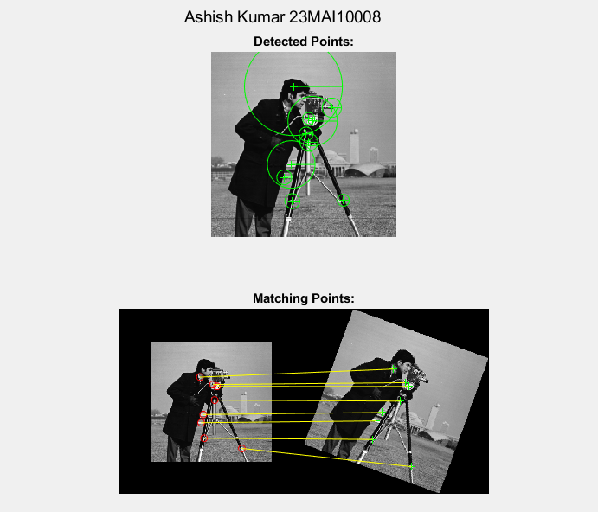

Learning outcomes :
- Learnt about the SIFT (Scale Invariant Feature Transform) Descriptor.
- Learnt about various steps to identify localized features.
- Learnt about the NLoG and DoG used in SIFT.
- Learnt about the concept of feature extraction.
- Learnt about how to match features in two images.

